Image | 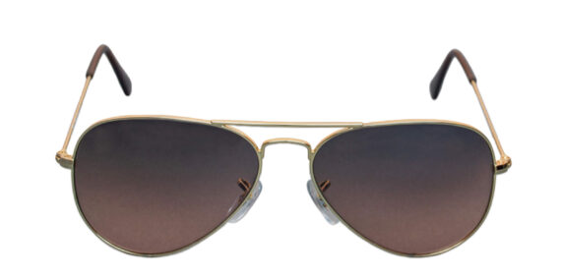
Brand | PRADA
Model Name | Bossy P-4597
Price | RS 2500
PRODUCT DETAILS

